SALT PLUS Application Form
Contact | Organization /  Company |  | Date | YYYY/MM/DD
 | Department |  | Applicant | Name:  Job Position:
 | Contact Information | Address:  TEL: E-mail:
Product | Code, Generic or Commercial Name:  Class of Drug (Biologics, Chemical or Natural Compound; First-in-Class vs. Best-in-Class)  MOA Target (enzyme, receptor, ligand etc.)  Disease and Primary Indication (if selected)  Formulation and Administrative Route  Competitors
Strategy | Target Product Profile (TPP) perspective, including special features  Market for Authorization (Asia, USA, EU or Others)
Current  R&D Stage | e.g., Discovery, Preclinical, Early/Late Phase Clinical, Extension of Indication, Post-marketing affairs etc.
Area of Consulting
Request Details | Use a separate page If you need more space to fill in inquires
Reference | Make a list of your research documents, website information, etc. on the product if necessary

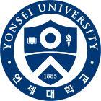 | University-Industry Foundation of Yonsei University Health System  Phone: 02-2228-0223(0224), Email: saltplus@yuhs.ac, Web:alynd.yuhs.or.kr | 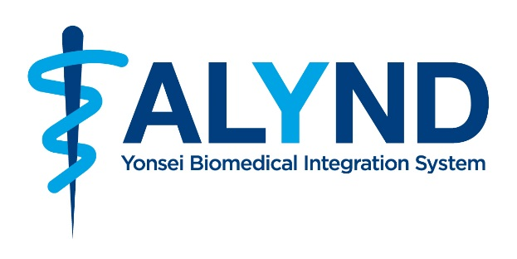
*ALYND: A Leading Yonsei Network for biopharmaceutical R&D

